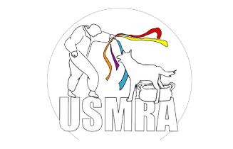
USMRA Frequently Asked Questions

With a change in the board and everything constantly evolving, we thought an easy to access sheet providing all the answers to your frequently asked questions would be the best solution! If you have any other questions or concerns, please do not hesitate to reach out to the Secretary at secretary@usmondioring.org.

Q: How do I bring a concern or suggestion forward to be reviewed by the Board of Directors?
A: All concerns and suggestions should be emailed to the secretary at secretary@usmondioring.org. Any concern brought forward to them 7 days before the BOD meeting ( Everything Third Monday of the Month ) will be included in that month’s agenda.

Q: Where can I find the agendas and minutes for future and past BOD meetings?
A: Agendas are posted on the USMRA website a week before the BOD meeting is scheduled.
Minutes from the meeting are posted on the USMRA website after being approved by the BOD at the following meeting ( EXAMPLE: January minutes are approved at the February meeting and they will be posted to the website in February ).

Q: I renewed my membership but it is still asking me to renew for the next year, was my membership processed?
A: If you completed all the steps appropriately and paid for your membership renewal, then your membership was processed. There is a slight delay in the website for the renewal banner to remove itself. If you are still seeing this banner 5 business days after renewing, please reach out to the secretary to get this resolved ASAP.

Q: How do I add a dog to my membership account?
A: A dog is added to your account after you have applied and been issued a scorebook. There is a short delay in the website updating, if you do not see your dog added to your account 5 business days after being issued a scorebook, please reach out to the secretary to get this resolved ASAP.

